**Ec2 integration with cloudwatch**

To create the IAM role necessary to run the CloudWatch agent on EC2 instances

1. Sign in to the AWS Management Console and open the IAM console at <https://console.aws.amazon.com/iam/>.
2. In the navigation pane on the left, choose Roles and then Create role.
3. Make sure that AWS service is selected under Trusted entity type.
4. For Use case, choose EC2 under Common use cases,
5. Choose Next.

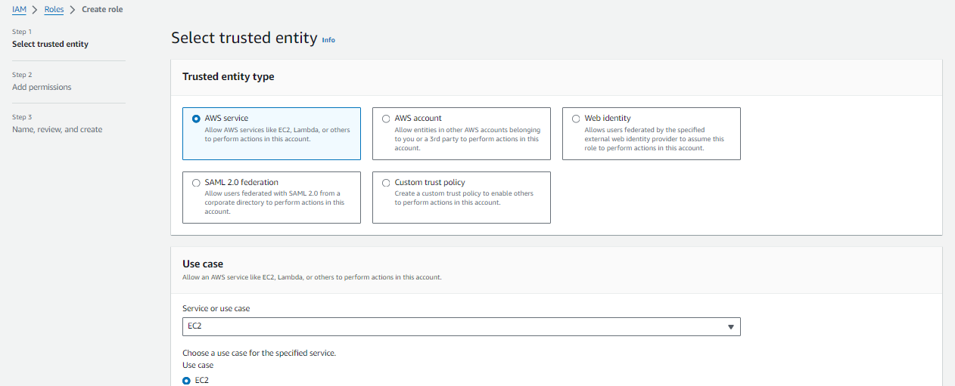

1. In **Role name**, enter a name for the role, such as *CloudWatchAgentServerRole*. Optionally give it a description. Then choose **Create role**.

The role is now created.

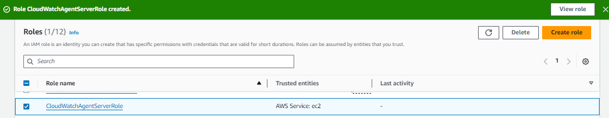

Create ec2 instance with above role and run below command

sudo yum install amazon-cloudwatch-agent

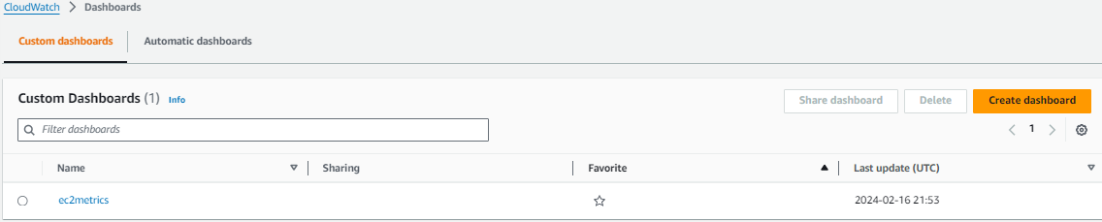

Created ec2 dashboard and enabled cpu utilization metrics enabled

